Name: Sachin Hansda

Roll No.: 111601019

DBMS Lab 2

Question 1:

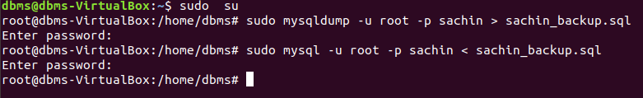

Question 2:

2.1: Create Database

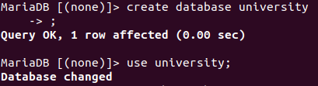

2.2: Import Schema



2.3: Login directly

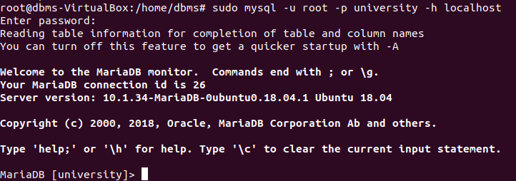

2.4: List the tables

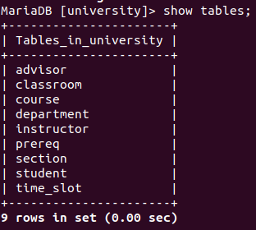

2.5: Course table

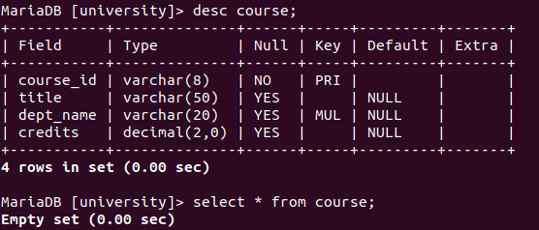

2.6: Import data



2.7: Course table

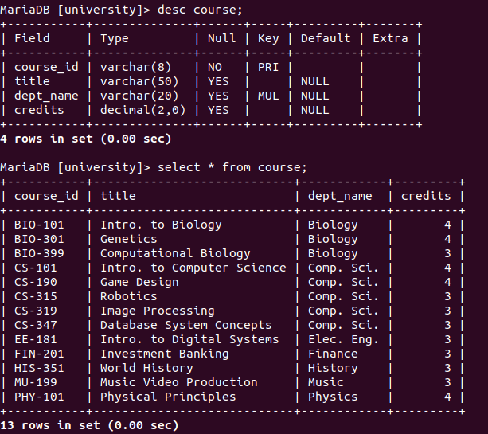

Question 3:

code:

CREATE TABLE `takes` (

`ID` varchar(5) NOT NULL DEFAULT '',

`course_id` varchar(8) NOT NULL DEFAULT '',

`sec_id` varchar(8) NOT NULL DEFAULT '',

`semester` varchar(6) NOT NULL DEFAULT '',

`year` decimal(4,0) NOT NULL DEFAULT '0',

`grade` varchar(2) DEFAULT NULL,

PRIMARY KEY(`ID`, `course_id`),

CONSTRAINT `takes_ibfk_1` FOREIGN KEY (`ID`) REFERENCES `student` (`ID`),

CONSTRAINT `takes_ibfk_2` FOREIGN KEY (`course_id`,`sec_id`,`semester`,`year`) REFERENCES `section` (`course_id`,`sec_id`,`semester`,`year`) ON DELETE CASCADE

) ENGINE=InnoDB DEFAULT CHARSET=utf8mb4;

CREATE TABLE `teaches` (

`ID` varchar(5) NOT NULL DEFAULT '',

`course_id` varchar(8) NOT NULL DEFAULT '',

`sec_id` varchar(8) NOT NULL DEFAULT '',

`semester` varchar(6) NOT NULL DEFAULT '',

`year` decimal(4,0) NOT NULL DEFAULT '0',

PRIMARY KEY(`ID`, `course_id`,`sec_id`,`semester`,`year`),

CONSTRAINT `teaches_ibfk_1` FOREIGN KEY (`ID`) REFERENCES `instructor` (`ID`) ON DELETE RESTRICT,

CONSTRAINT `teaches_ibfk_2` FOREIGN KEY (`course_id`,`sec_id`,`semester`,`year`) REFERENCES `section` (`course_id`,`sec_id`,`semester`,`year`) ON DELETE CASCADE

) ENGINE=InnoDB DEFAULT CHARSET=utf8mb4;

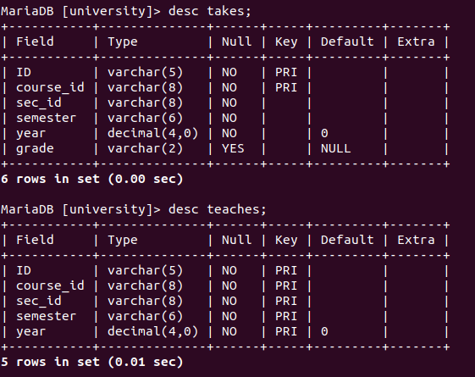output:

Question 4:

code:

insert into teaches values('10101', 'CS-347', '1', 'Fall', '2009');

insert into teaches values('12121', 'FIN-201', '1', 'Spring', '2010');

insert into teaches values('22222', 'PHY-101', '1', 'Fall', '2009');

insert into teaches values('32343', 'HIS-351', '1', 'Spring', '2010');

insert into teaches values('45565', 'CS-101', '1', 'Spring', '2010');

insert into teaches values('45565', 'CS-319', '1', 'Spring', '2010');

insert into teaches values('76766', 'BIO-101', '1', 'Summer', '2009');

insert into teaches values('76766', 'BIO-301', '1', 'Summer', '2010');

insert into teaches values('83821', 'CS-190', '1', 'Spring', '2009');

insert into teaches values('83821', 'CS-190', '2', 'Spring', '2009');

insert into teaches values('83821', 'CS-319', '2', 'Spring', '2010');

insert into teaches values('98345', 'EE-181', '1', 'Spring', '2009');

insert into takes values('00128', 'CS-101', '1', 'Fall', '2009', 'A');

insert into takes values('00128', 'CS-347', '1', 'Fall', '2009', 'A-');

insert into takes values('12345', 'CS-101', '1', 'Fall', '2009', 'C');

insert into takes values('12345', 'CS-190', '2', 'Spring', '2009', 'A');

insert into takes values('12345', 'CS-315', '1', 'Spring', '2010', 'S');

insert into takes values('12345', 'CS-347', '1', 'Fall', '2009', 'A');

insert into takes values('19991', 'HIS-351', '1', 'Spring', '2010', 'B');

insert into takes values('23121', 'FIN-201', '1', 'Spring', '2010', 'C+');

output:

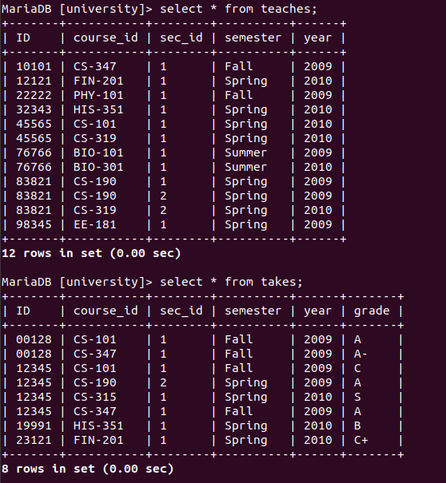

Question 5:

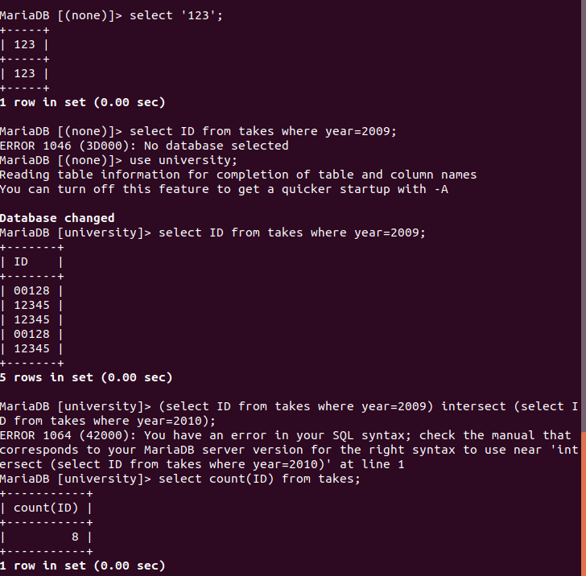

Question 6:

6.1:

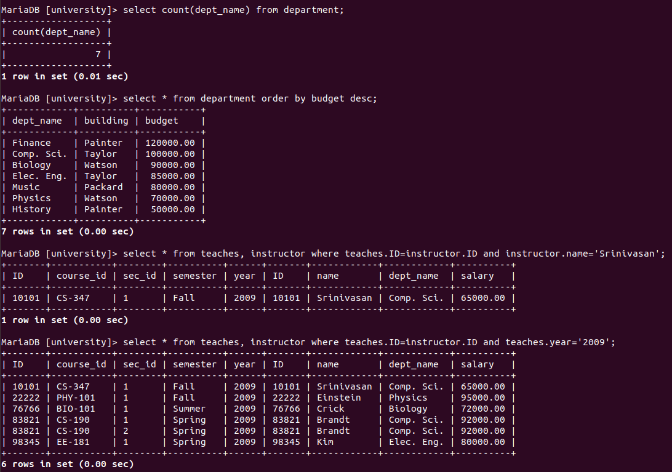

6.2:



6.3:

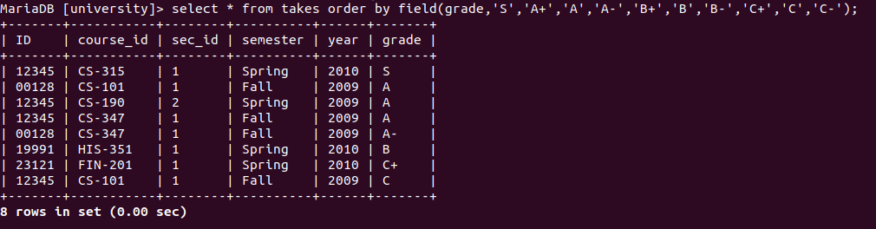

6.4:

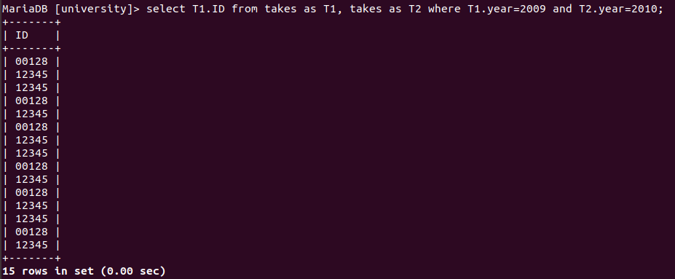

6.5:

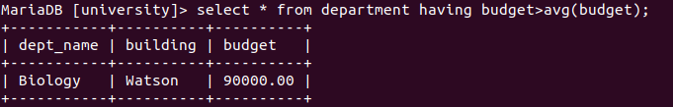

6.6:



6.7:



6.8:

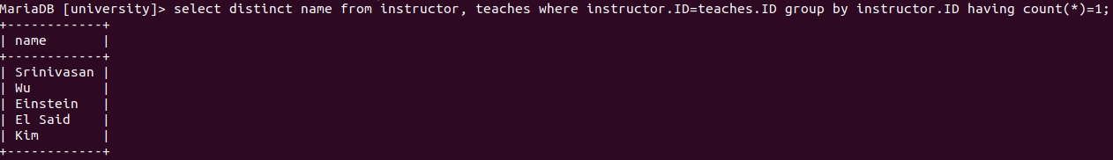

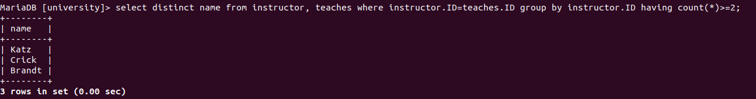6.9:

6.10:

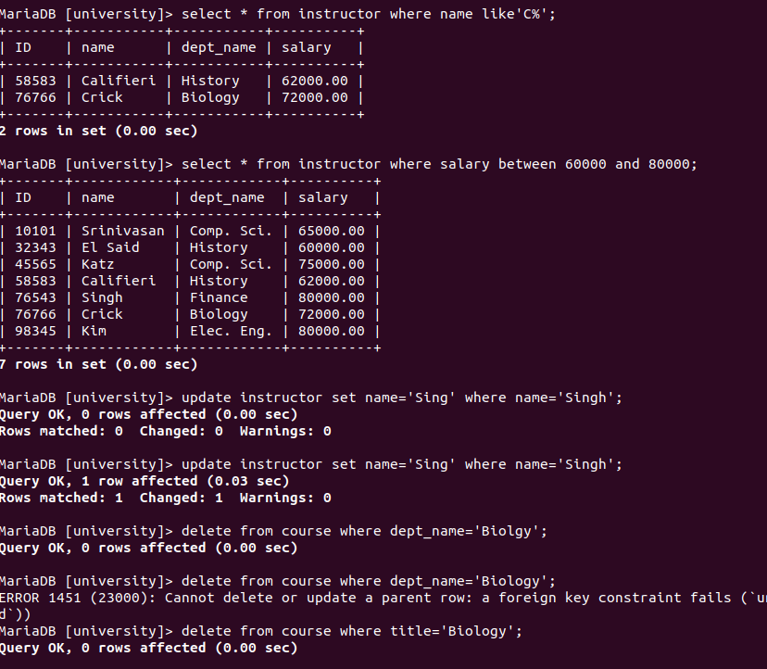

6.11:



6.12:



6.13:

